

**COLLEGE OF COMPUTING AND INFORMATION SCIENCES**

**SCHOOL OF COMPUTING AND INFORMATION SCIENCES**

**BACHELOR OF SCIENCE IN SOFTWARE ENGINEERING**

**RECESS GROUP DATA SCIENCE MINI PROJECT *IMPLEMENTATION DOCUMENT***

|  |  |  |
| --- | --- | --- |
| **NAME** | STUDENT NUMBER | **REGISTRATION NUMBER** |
| MUSINGUZI JOSEPH | **217015788** | 17/U/6671/PS |
| MUKWATSE COLLIN | **217012303** | 17/U/6509/PS |
| KALANZI TONNY | **217015739** | 17/U/4463/EVE |
| BETARIZA ALVIN | **217012330** | 17/U/3574/PS |

**VISUALIZATIONS DONE**

***Player clustering***

Under this section players were grouped according to age, nationality and playing position and a tally made. This insight can give club scouts an idea of possible areas where to recruit players for their club.

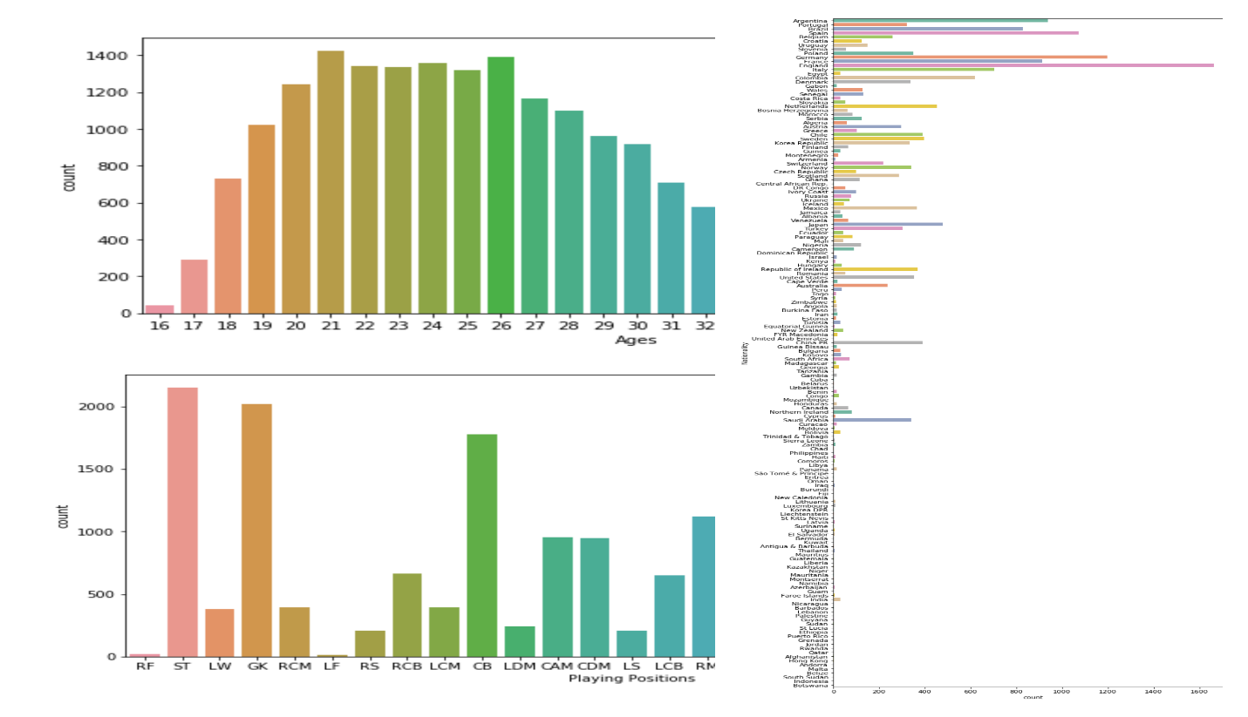

***Dream team***

All players were gauged according to a set of attributes to play a given position in order to find out the best squad for a dream team given a user selected formation (4-3-3 in this case). The 5 highest scores were plotted as bar plots in descending order. This can be used by fans to determine the best players when playing the FIFA video game in order to gain a competitive advantage of their opponents.

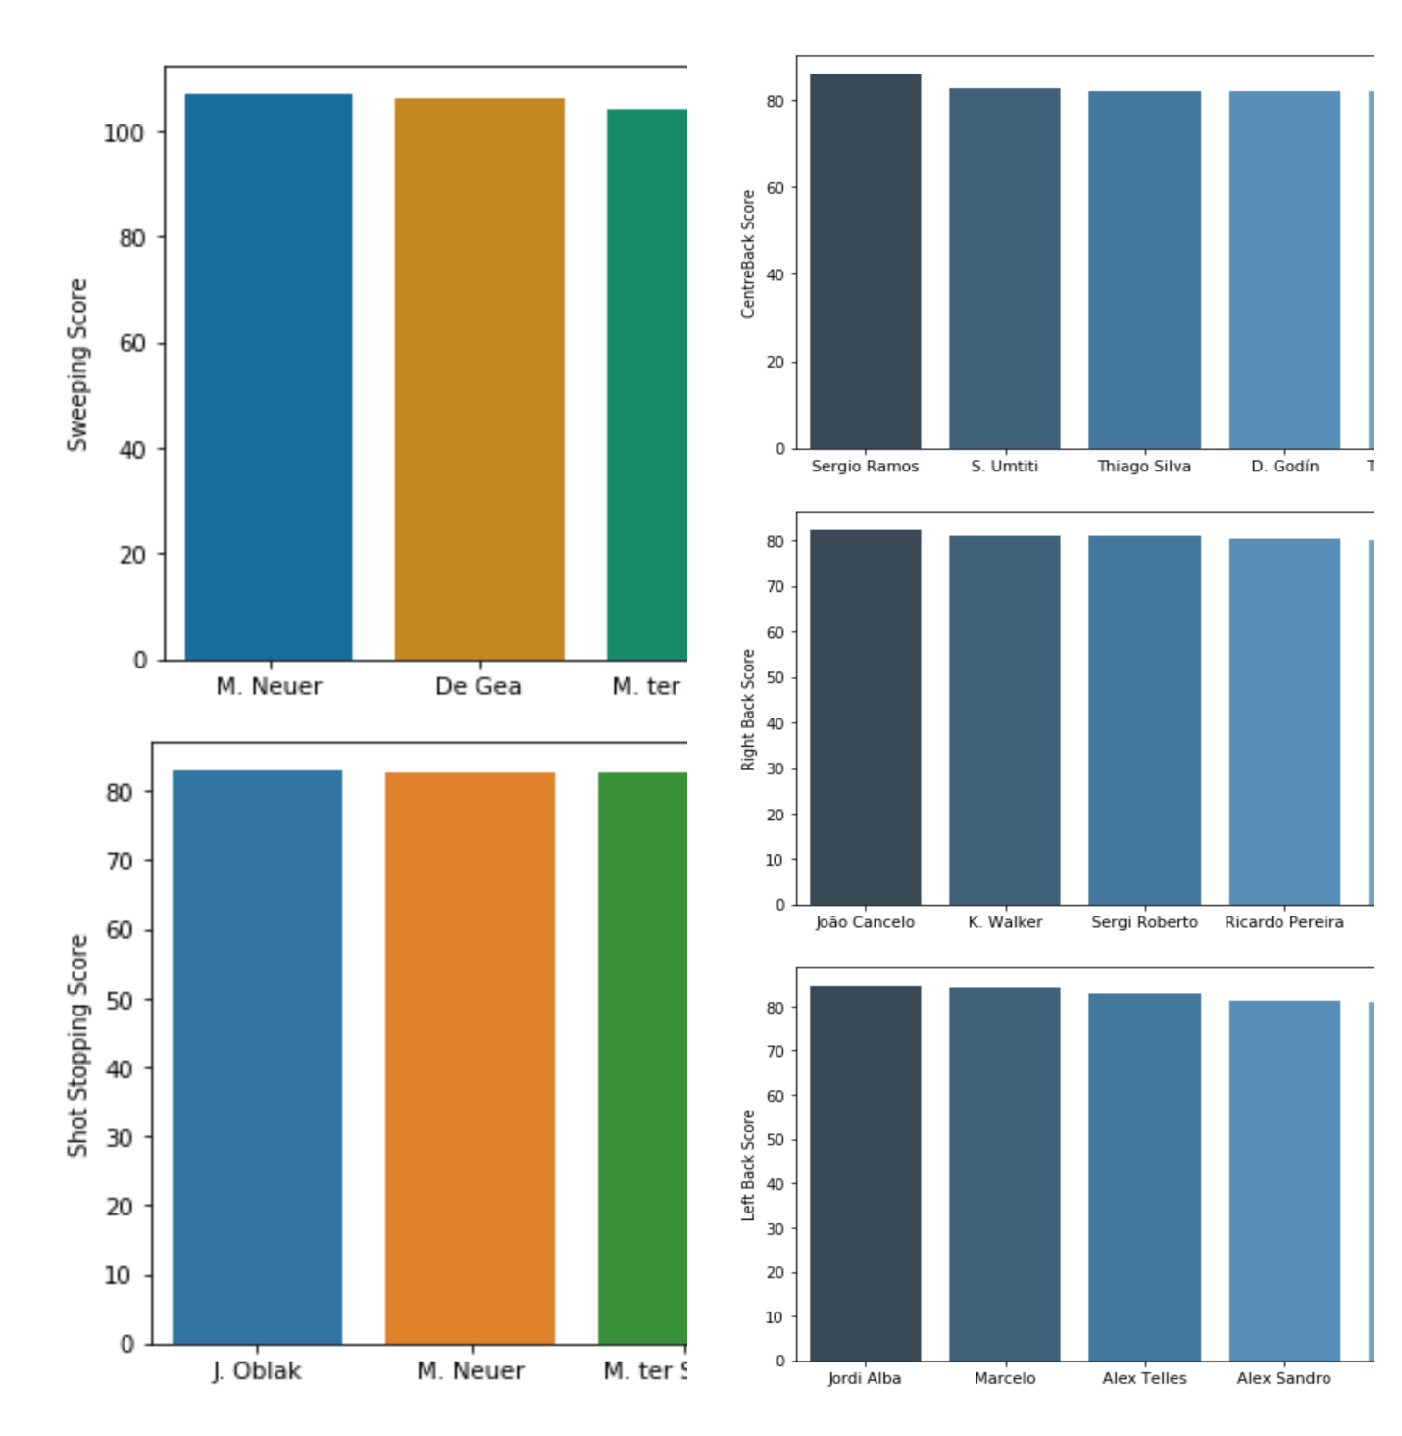

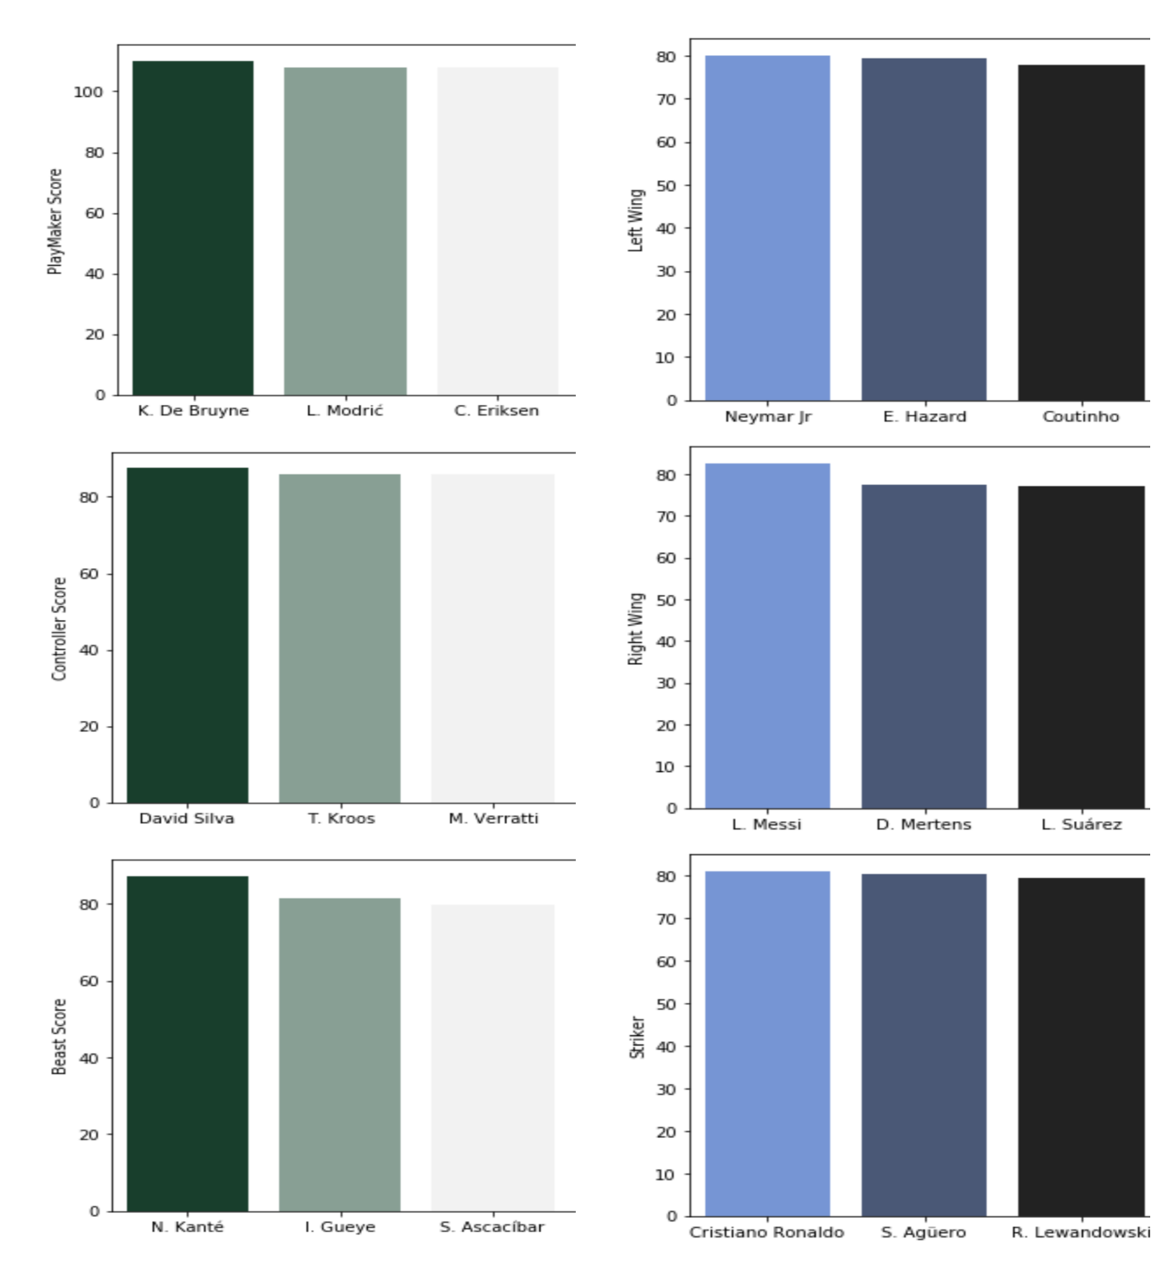

***Correlation***

There are around 35 skills across which all the players have been rated. These ratings contribute to the player’s overall rating and potential. The heatmap, which is a color-coded scale of correlation coefficient gives a quick overview of which skills are highly correlated and which are negatively correlated. The darker the color of the square, the more is the correlation. This can be used by mangers and football scouts in player selection for matches, fans can use it when playing fantasy football and the FIFA video game.

